Statistics for engineers. Exercise sheet 3: Estimation

1. The data given below is the weight of a finished component in grams. The customer specification states that the population mean should be 50 grams.

47.9 50.2 54.4 45.7 52.6 49.2 51.6 46.9 47.1 50.8 50.0 47.9 48.7 48.1 51.0

Calculate the mean and standard deviation for this set of data. If you were the customer would you be happy to receive product from this supplier?

2. A designer has developed new machine part which he claims has an average life of 60 hours before needing replacement. A manufacturer puts 9 of these parts into his machines and observes the time to replacement of each part. The times, in hours, are given below:

58.6 59.3 61.0 60.2 59.7 58.1 60.4 61.3 57.9

a) Find the sample mean and variance for this set of data.
b) On the basis of this sample evidence would you be inclined to believe the claim of the designer that the average life is 60 hours?

3. a) Take a sample of four friends of the same gender and ask their height. Calculate the mean and standard deviation of this sample.
b) Take a sample of a different set of four people of the same gender as part (a) above. Calculate the mean and standard deviation for this sample.
c) Compare the results obtained in parts (a) and (b).
d) Combine the data from your two samples and calculate the mean and standard deviation for your sample of size 8. Compare these results with your previous results in parts (a) and (b).

4. The table given below shows the salaries in £000s for a group of workers in a specific job.
a) Calculate the mean, standard deviation, median and interquartile range for this set of data. Explain what is meant by each of these sample statistics.
b) Draw the graph of the cumulative frequency against the salary. Mark on this graph the median and quartiles.

 | Number of
Salary | workers
6 and < 8 | 200
8 and < 10 | 359
10 and < 12 | 540
12 and < 14 | 900
14 and < 16 | 1251
16 and < 18 | 1779
18 and < 20 | 1520
20 and < 22 | 701
22 and < 24 | 436
24 and < 26 | 299
26 and < 28 | 98
28 and < 30 | 50
c) The employees doing this work at Gradgrind PLC are presently paid £9,500 per annum. They are seeking a rise in salary to £10,500 per annum. If pay is the only factor to be taken into account would you grant the pay rise? Give the reasons for your answer.

5. A manufacturer of household electrical goods maintains an emergency repair service as part of the after sales service. This service is available every day of the year. The country is divided into a number of service areas. The number of repairs per day dealt with by the largest area over the last two years has been recorded and the information is given below.

Number of | Number of days with
repairs | this number of repairs
0 | 12
1 | 48
2 | 114
3 | 156
4 | 131
5 | 111
6 | 90
7 | 42
8 | 11
9 | 11
10 | 4
Calculate the mean number of repairs per day and the standard deviation of the number of repairs.
Calculate the median number of repairs per day and the quartiles for this set of data.
What inferences can be made concerning the distribution of the number of repairs per day?

6. The table below shows the number (in thousands) of male marriages by age for the year 1938 (same as your notes) and the year 1977.

Age | Number of marriages | Number of marriages
 | 1938 | 1977
<21 | 14.1 | 59.9
21-24 | 117.7 | 137.2
25-29 | 156.2 | 92.7
30-34 | 60.1 | 41.8
35-44 | 33.9 | 33.7
45-54 | 13.0 | 18.7
55 & over | 12.4 | 19.9

a) Calculate the percentage cumulative frequencies for both set of data. On the same graph plot the percentage cumulative frequency curves for male marriages in 1938 and 1977.
b) Use the information from the plots of the percentage cumulative frquency curves to determine whether or not there has been a change in the pattern of marriage age for males between 1938 and 1977. Give clear, concise reasoning to support your arguments.

Estimation Exercise Solutions

1. Call the weight y. Using a calculator the sample mean is 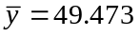 grams, this is the best estimate of the population mean 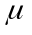. The sample standard deviation is 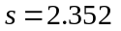 grams , this is the best estimate of , the population standard deviation. The sample size is n=15.
If the population mean should be 50 grams the value of the sample mean is not far off this. However, the sample standard deviation of 2.352 grams is rather worrying, a spread of approximately 3 standard deviations either side of the mean (although only approximated by ) would suggest a population varying between approx. 43 grams and 55 grams. A large degree of variability is never very desirable.

2. Call the life of the part y.
a) The sample size is n=9. Using the calculator sample mean is 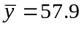 hours, the sample standard deviation is 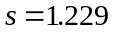 hours. The sample variance is 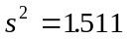.
b) The sample mean is the best estimate of , the population mean. Since the sample mean of 57.9 min is quite a long way from 60 hours it is likely that the claim is not true. In order to test this a t-test which is described in later notes should be carried out.

3. You should see that the sample mean and standard deviation is slightly different in the two samples.

4. a) First make a table with the midpoints of each class interval. This is then used together with the frequency to calculate the sample mean and sample standard deviation. Call the salary y, measured in £000s. The sample mean is then =£6.781 thousand, the sample standard deviation is s=£4.303 thousand.

 | Mid-point | Number of | Cumulative
Salary | y | workers, f | frequency
6 and < 8 | (6+8)/2=7 | 200 | 200
8 and < 10 | (8+10)/2=9 | 359 | 200+359=559
10 and < 12 | 11 | 540 | 559+540=1099
12 and < 14 | 13 | 900 | 1999
14 and < 16 | 15 | 1251 | 3250 | ----Q₁ Group
16 and < 18 | 17 | 1779 | 5029 | ----Median group
18 and < 20 | 19 | 1520 | 6549 | ----Q₃ Group
20 and < 22 | 21 | 701 | 7250
22 and < 24 | 23 | 436 | 7686
24 and < 26 | 25 | 299 | 7985
26 and < 28 | 27 | 98 | 8083
28 and < 30 | 29 | 50 | 8133
The median and quartiles are calculated using the cumulative frequencies.
The median is the value of the middle salary, 50% of the workers earn the median salary or less. The total number of workers is 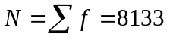. The median is the value of the N/2=8133/2=4066.5th salary.
A cumulative frequency of 3250 corresponds to a salary of £16,000.
A cumulative frequency of 5029 corresponds to a salary of £18,000.
A cumulative frequency of 4066.5 corresponds to the Median.
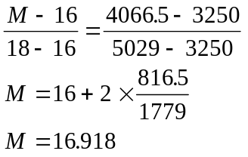
The median value is £16.918 thousand.
The lower quartile, Q1 is the value of the N/4=2033.25th salary.
A cumulative frequency of 1999 corresponds to a salary of £14,000.
A cumulative frequency of 3250 corresponds to a salary of £16,000.
A cumulative frequency of 2033.25 corresponds to the lower quartile.
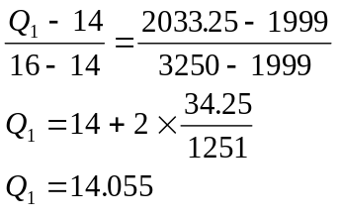
The lower quartile is Q₁=£14.055 thousand.
The upper quartile, Q₃ is the value of the 6099.75th salary.
A cumulative frequency of 5029 corresponds to a salary of £18,000.
A cumulative frequency of 6549 corresponds to a salary of £20,000.
A cumulative frequency of 6099.75 corresponds to the upper quartile.
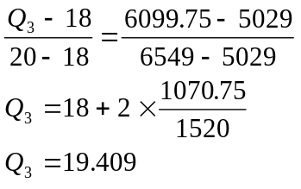
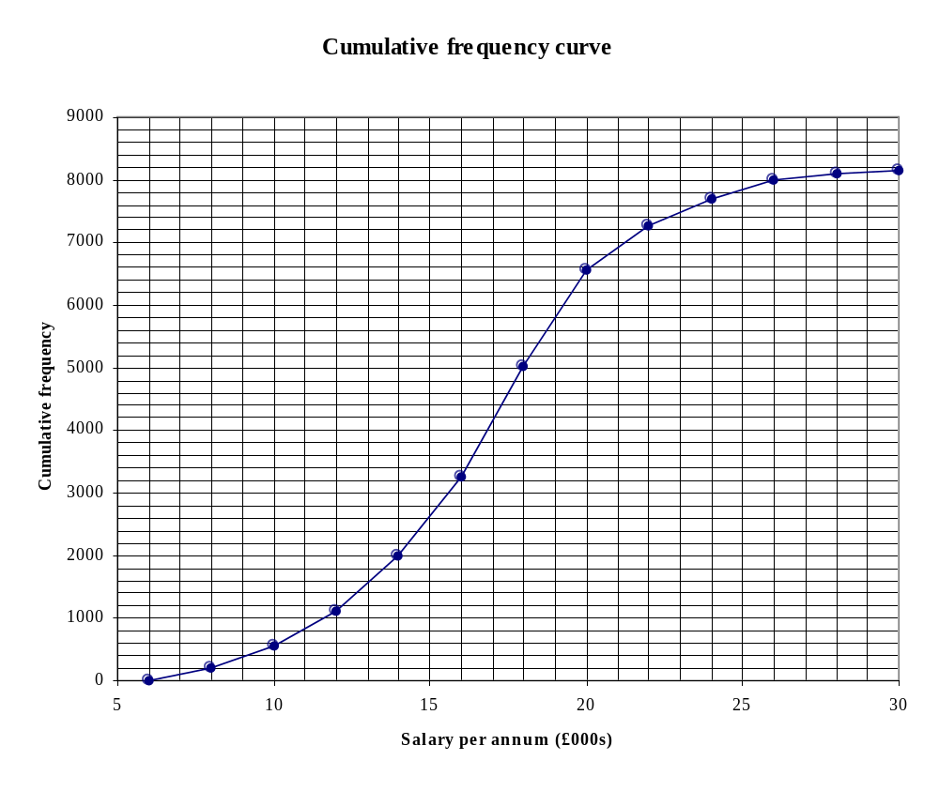

The upper quartile is £19.409 thousand.
The interquartile range is 19.409-14.055=£5.354 thousand.
The sample mean is the best estimate of , the population mean.
The sample standard deviation is the best estimate of , the population standard deviation.
The median is the middle value, 50% of salaries are £14,055 or less.
The sample mean and the median are both measures of location.
The sample standard deviation and the interquartile range are both measures of spread.
The middle 50% of salaries have a spread of £5,354 .
25% of salaries are £14,055 or less ; 75% of salaries are £19,409 or less.

To mark the median and quartiles on the graph:
Draw a horizontal line from cumulative frequency axis at 4066.5 to the curve and then a vertical line from the salary axis to the intersection of the 4066.5 line and the curve.
Carry out the same procedure for cumulative frequencies of 2033.25 and 6099.75 to find the quartiles.
The EXCEL spreadsheet file for this question is in the TRAINING directory with the filename EST_EXER.XLS
The spreadsheet contains graphs for the % cumulative frequency as well as the graph shown above. This sometimes more useful when finding the median and quartiles.
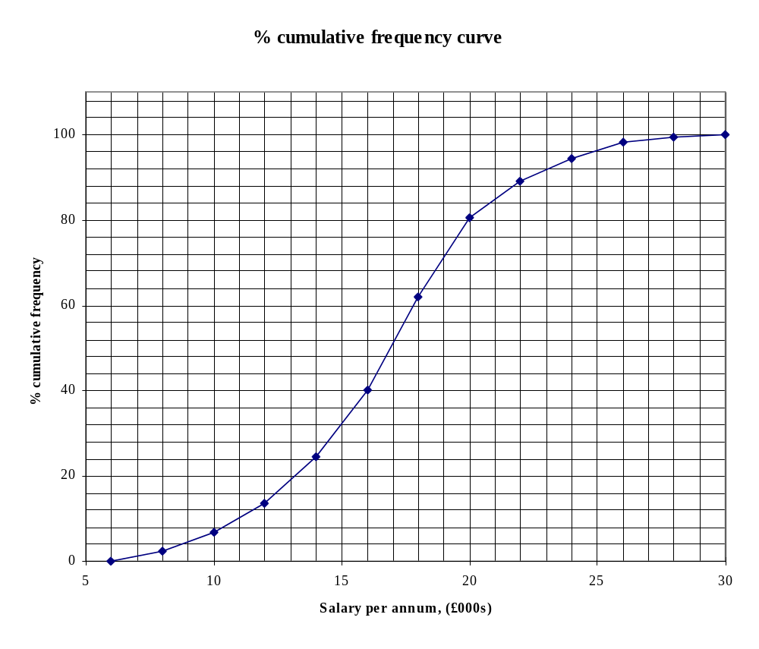
c) From the percentage cumulative frequency curve it is possible to read off the value corresponding to a salary of £9,500 as 6%; i.e. 6% of the workers earn £9,500 or less. Similarly approximately 10% of the workforce earn £10,500 or less. It would appear that the workers have a good case for a rise in salaries.

5. Call the number of repairs per day y. Note that y is a discrete variable, fractional values are not possible.

Number of | Number of days with | Cumulative
repairs | this number of repairs | frequency
0 | 12 | 12
1 | 48 | 60
2 | 114 | 174
3 | 156 | 330 | ----Q₁ group
4 | 131 | 461 | ----Median group
5 | 111 | 572 | ----Q₃ group
6 | 90 | 662
7 | 42 | 704
8 | 11 | 715
9 | 11 | 726
10 | 4 | 730
Since y may take only integer values the number of repairs as set out is used, all of the values within each group are exactly the same. Using a calculator (remember to enter the zero as a value) the sample mean is found as = 3.95 repairs per day, 4 to the nearest integer. The sample standard deviation is found as s=1.92 repairs per day, 2 to the nearest integer. NOTE: The values 3.95 and 1.92 are used for any further calculations not the nearest integer values.
To find the median and quartiles it is necessary to calculate the cumulative frequencies.
The total frequency is N=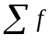=730 .
The median is the value of the N/2th =365th item. There are 330 days on which 3 or less repairs are done. There are 461 days on which 4 or less repairs are done. Since all the no. of repairs in the median group are the same there is no need to interpolate, the median is 4 repairs per day. Similar thinking gives a lower quartile value of Q₁=3 repairs per day and an upper quartile value of Q₃=5 repairs per day.
The mean and the median are the same for a symmetric distribution. In this case the sample mean is 3.94 and the median is 4, it would appear to be a symmetric distribution. Since y is a discrete variable strictly speaking it can not be normally distribute but for a large sample it may be considered to be approximately normally distributed.

6. First find the cumulative frequencies. The choice of upper limit for the last class interval is subjective. It is common to use the same class interval as that used for the preceding group.

Calculation of the median and quartiles graphically
 |  |  | 1938 |  | 1977 | % 1938 | % 1977
Age interval |  |  | 1938 | cum. | 1977 | cum. | cum. | cum.
lower | upper | frequency | frequency | frequency | frequency | frequency | frequency
 | 16 |  | 0 |  | 0 | 0 | 0
16 | 21 | 14.1 | 14.1 | 59.9 | 59.9 | 3.5 | 14.8
21 | 25 | 117.7 | 131.8 | 137.2 | 197.1 | 32.4 | 48.8
25 | 30 | 156.2 | 288.0 | 92.7 | 289.8 | 70.7 | 71.8
30 | 35 | 60.1 | 348.1 | 41.8 | 331.6 | 85.4 | 82.1
35 | 45 | 33.9 | 382.0 | 33.7 | 365.3 | 93.8 | 90.4
45 | 55 | 13.0 | 395.0 | 18.7 | 384.0 | 97.0 | 95.1
55 | 75 | 12.4 | 407.4 | 19.9 | 403.9 | 100.0 | 100.0
The table shows the spreadsheet layout which was used to plot the graphs of the % cumulative frequencies.
In order to compare the 1977 population with the 1938 population it is necessary to compare the proportions of the populations; e.g. the age of the lower 10%, the age of the lowest 20% etc. It is easier to do this if the percentage cumulative frequency curve is used. The chart for the graph given below is in the file named EST_EXER.XLS. Copy the file to your own disk and try adding the % cum. freq. curve. Follow the pattern used in Question 4.
